Section C — Mini Capstone Project
Mini Project: Food Delivery REST API Backend Objective: Build a fully functional REST API backend for a food delivery platform that combines ModelSerializer, ModelViewSet, DefaultRouter, PageNumberPagination, and TokenAuthentication into a single deployable Django project.
Your project must:
1.The API must expose full CRUD endpoints for three resources — Category, MenuItem, and Order — each managed through a ModelViewSet registered with a DefaultRouter.
2.All serializers must use ModelSerializer with appropriate field-level validation (e.g. price > 0, quantity >= 1, non-empty name).
3.The Order creation and order history endpoints must be protected with TokenAuthentication and IsAuthenticated; unauthenticated requests must receive HTTP 401.
4.The Order listing endpoint must be paginated using PageNumberPagination (page_size = 5) and support filtering by order status via a query parameter.
5. Submit the complete project folder with models.py, serializers.py, views.py, urls.py, and a README listing all API endpoints with sample Postman screenshots.

Ans=
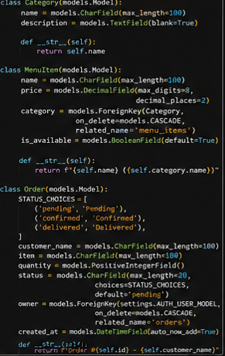
2
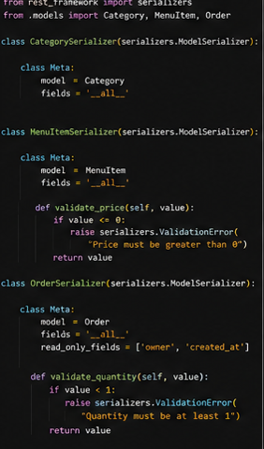
3
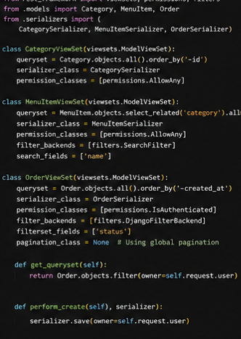
4
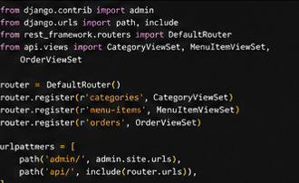
5
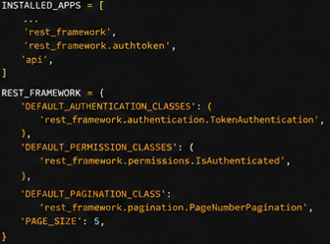
6
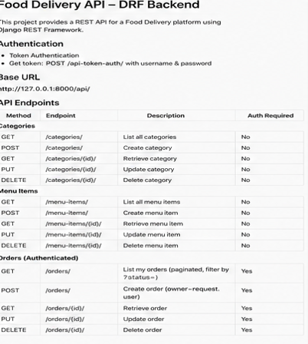
7
